MECHATRONICS SYSTEMS PROGRAMMING I

Unit Code: EMT 3104

CAT 2

REPORT 3: A REVIEW OF SPI AND I2C

Student: NJERI NEWTON KARIUKI

Reg. Number: E022-01-0794/2019

Submission Date: 2nd August, 2021

Question a

Persistence of Vision
Definition: Persistence of Vision (POV) – it is a form of optical illusion where the eye’s perception of an object is not fast enough to see how an object is changing; it is slower than the rate of change of the object.
POV technique is employed where the number of pins available in a microcontroller are less than the required. This inadequacy of pins is mostly present when dealing with LCDs or 7-segment displays. It is preferred to multiplexers and display drivers because it is relatively cheap, actually it has no additional costs associated with it.

POV with 3 Seven-Segment Displays
POV technique is employed for display using three seven-segment displays as discussed below. Common Cathode 7-segment displays are used for this discussion.
Common cathode 7-segment displays are configured as shown below:
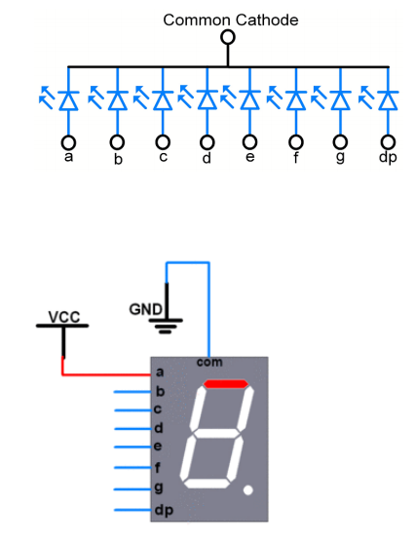

To light up one segment, the anode of that segment is set high i.e. is assigned a voltage higher than that of the cathode. Each segment’s anode can be connected to a microcontroller pin and the cathode connected to the ground. Numbers are displayed by setting high certain segments while the rest are low.
Since were are using 3 seven-segment displays, by employing POV we only require 11 pins as shown in the circuit below.
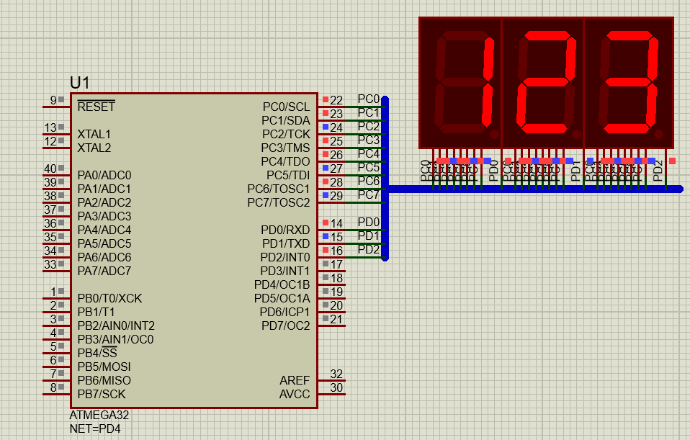
By using POV technique the eye is tricked as if the three displays are simultaneous although in the real sense they are just alternating.
As shown in the circuit all anodes of the 3 displays are connected to the microcontroller’s PORT C pins, and their cathodes are connected to pins PD0, PD1 and PD2 of PORTD respectively when the first 7-segment display is the one on the far left. In this explanation, the set-up is used to display a number between 0 and 999 let’s say 123.

Pseudo-code
Start program
Initialize array numbers = {0x3f, 0x06, 0x5b, 0x4f}
Initialize variable DDRC = 0xff
Initialize variable DDRD = 0x7
Start infinite loop
Initialize variable PORTC = numbers [1]
Initialize variable PORTD = 0x6
Call function delay for 1ms
Initialize variable PORTD = 0x7

Initialize variable PORTC = numbers [2]
Initialize variable PORTD = 0x5
Call function delay for 1ms
Initialize variable PORTD = 0x7

Initialize variable PORTC = numbers [3]
Initialize variable PORTD = 0x3
Call function delay for 1ms
Initialize variable PORTD = 0x7
Stop infinite loop
Stop program

To display 123, the first 7-segment displays 1, the second 2, and the third one displays 3. To display 1, the second and third 7-segments are put off, by setting their respective cathodes high. The cathode of the first segment is set low, since this is the one used to display at the moment. To display one, pins PC1 and PC2 are set high while the rest pins on PORTC low.
The first and third 7-segments are then set off by setting their cathode pins high, cathode of the second 7-segment is set low, thus, it is used to display the second digit which for our case is 2. The pins PC0, PC1, PC3, PC4 and PC6 are set high and the rest low.
The third digit is displayed in the third 7-segment display, thus its cathode is set low, while the cathodes of the other 7-segments are set high. The digit to be displayed is then displayed by setting the necessary pins high and the rest low. In this case 3 is displayed, thus pins PC0, PC1, PC2, PC3, and PC6.
After this, the lines of code displaying the three digits one at a time, is looped at a speed that is fast enough to trick the eye that they are simultaneous.

Question b

Hardware Debouncing
Hardware debouncing involves adding a capacitor and a resistor to the circuit to even out the bounce of a switch into a more gradual curve. The value of the capacitor used depends on the circuit, its operating voltage, current etc.
This method of debouncing is also referred to as R-C debouncing since its circuit involves RC network. The capacitor filters the instant charges in the signal produced as a result of bouncing of the switch. It does so by storing charge and releasing it with each bounce smoothing out the connection process. When the switch is in open state the voltage the voltage across the capacitor is zero. Initially when the switch is open, the capacitor charges through resistors R1 and R2. This can be seen from the RC debouncing circuit shown below.
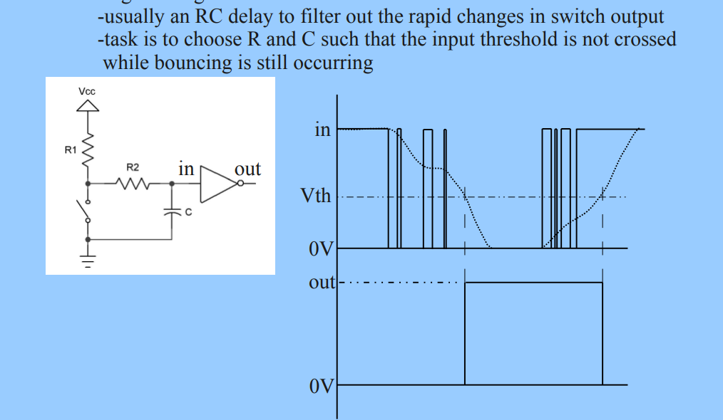
The values of the capacitor and the resistors used can be calculated from the following equations:
Vc = Vs (1-e ^ (-t/RC))
T = RC
Where:
- Vc is the voltage of the capacitor
- Vs is the voltage of the source
- t is the time in seconds
- R is the resistance in ohms
- C is the capacitance in Farads
- T is the time constant
Charging a capacitor for one time constant will result in 63% charge, for 2T 86% charge and for 3T 95% charge. The time constant T, also governs the discharging of a capacitor too. After one time constant a fully charged capacitor will discharge to 37% of its original charge after 2T 13.5%.
From the above relationship of T and charging of a capacitor, it is guaranteed that a capacitor will be fully charged or discharged within 5 time constants. Knowing this is important as it helps in determining the value of R and C to make the capacitor charge quickly or slowly.
For debouncing RC circuits the capacitor is to charge slowly relative to the voltage spikes created by the switch bounce and fast compared to a switch press. Keeping this in mind we can pick the values of R and C and assuming voltage spikes will be no longer than 100 microseconds:
R = 10kOhms
C = 10 microfarads
T = RC = 10000*10 ^-6 = 0.01 seconds
Slowest possible voltage spike = 100microseconds
T = 0.01 s = 10000microseconds
T is much large than 100 microseconds thus, thus the capacitor will smooth out all the bounce noise. This is shown below, the first diagram show the input be for debouncing, the next one shows input after debouncing.
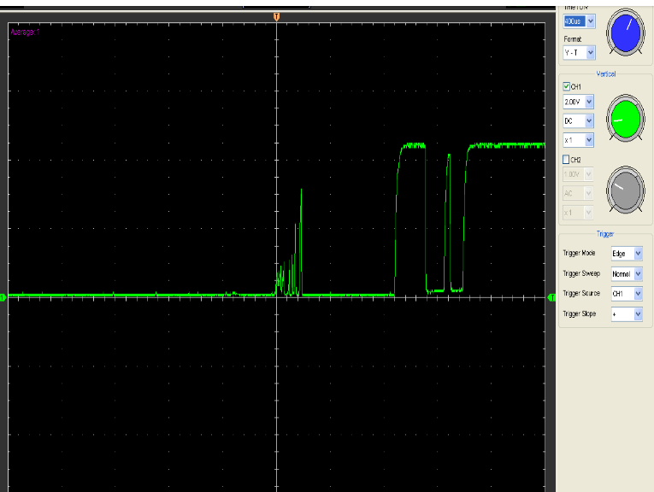
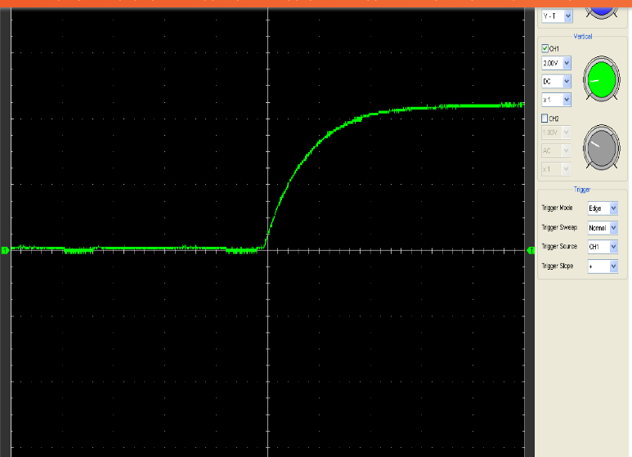
Although a handy way to debounce a switch, it comes at some costs, that is, the capacitor and the resistor increases the size of the board, for large projects producing many boards it results to increased cost of production as in each board a capacitor and a resistor are included to debounce a switch.

Software Debouncing
This is another way to debounce a switch, especially if the switch is being connected to an intelligent device such as a microcontroller. The simplest way to debounce in software is to simply tell the intelligent device to wait for 50ms after it detects the first pulse before checking again.

Pseudo-code
Start program
Initialize variables for pins to be used
Start infinite loop
Read value of the pin connected to the switch
Call delay function for 50ms
Stop infinite loop
Stop program

This method works well for small projects involving a single switch and in which there are no other inputs to be read. However, for projects involving a number of switches, the 50ms adds up making the project much slower and laggy. Also a lot can happen while the microcontroller is stuck waiting for 50ms.
A better software approach to debounce a switch is to use an interrupt. The interrupt may be triggered on both the rising and falling edges; i.e. when the switch is being closed and being open respectively

REPORT 3: A review of SPI and I2C

Introduction
SPI (Serial Peripheral interface) and I2C (Inter Integrated Circuit) are modern serial protocols. SPI is faster and better suited for small devices when compared to I2C, which is slower but can be extended up to a network of 128 devices using two wires and ground.

Serial Peripheral Interface (SPI)
As mentioned in the introduction section SPIs are suitable for use where a lot of data need to be moved faster between few devices. The reason for its high speed is that, it is a synchronous/clocked protocol.
An SPI has four wires, transmitting line, receiving line, a clock line that synchronizes the communicating devices and a data framing line.
Data framing - knowing where one byte starts and where the previous one ends.
SPI devices also have 8-bit shift registers to send and receive data. Whenever a master needs to send data, it places the data on this register and generates a required clock. Whenever a master wants to read data, the slave places data on the shift register and the master generates a clock.

Set up of SPI

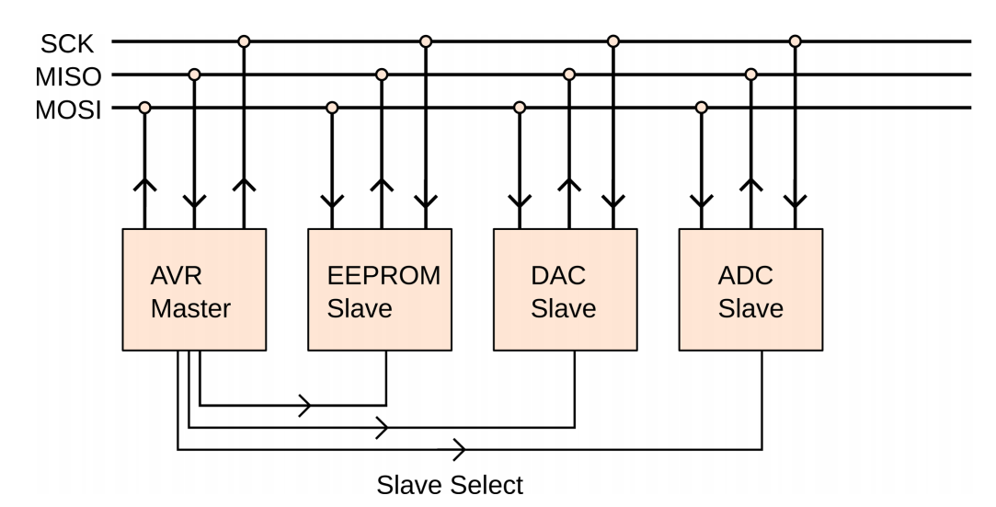
Figure 1 SPI Set up
Master device – Responsible for generating the clock signal (SCK) that all of the slave devices receive. Both master and slave devices use the clock signal to synchronize their voltages on the data lines MOSI and MISO i.e. Master-out-slave-in and Master-in-slave-out lines respectively. The master device sets the voltage level on the MOSI line while the slave device sets the voltage level on the MISO line.
There is one slave-select/chip-select line per slave device that controls which slave device is currently active.
It is important to note that on every clock tick both the master and the slave devices receive and transmit a bit of data on their respective lines. This implies that both devices are sending and receiving all the time.
As stated earlier SPI are limited to a small network of devices, this is as a result of the requirement of a wire per device.

Atmega32 SPI Communication
Atmega32 has an inbuilt SPI module. It can act as a master and slave SPI device. SPI communication pins in atmega32 are:
- MISO (Master in Slave out) – The master receives data and the slave transmits data through this pin.
- MOSI (Master out Slave in) – The master transmits data and the slave receives data through this pin.
- SCK (Shift Clock) – The master generates this clock for communication with the slave.
- SS (Slave Select) – Master can select slave device using this pin.
SPI pins | Pin No. in  Atmega32 | Pin Direction in  Master Mode | Pin Direction in  Slave Mode
MISO | 7(PB6) | Input | Output
MOSI | 6(PB5) | Output | Input
SCK | 8(PB7) | Output | Input
SS | 5(PB4) | Output | Input

AVR atmega32 uses three registers to configure SPI communication. These registers are:
- SPI Control Register
- SPI Status Register
- SPI Data Register

SPI Control Register: SPCR
SPIE | SPE | DORD | MSTR | CPOL | CPHA | SPR1 | SPR0
7 6 5 4 3 2 1 0
Bit 7 – SPIE: SPI Interrupt Enable bit
1 = Enable SPI interrupt
0 = Disable SPI interrupt
Bit 6 – SPE SPI Enable bit
1 = Enable SPI
0 = Disable SPI
Bit 5 – DORD: Data Order bit
1 = LSB (Least Significant Bit) transmitted first
0 = MSB (Most Significant Bit) transmitted first
Bit 4 – MSTR: Master Slave Select bit
1 = Master mode
0 = Slave mode
Bit 3 – CPOL: Clock Polarity Select bit
1 = Clock start from logical one
0 = Clock start from logical zero
Bit 2 – CPHA: Clock Phase Select bit
1 = Data sample on trailing clock edge
0 = Data sample on the leading clock edge
Bit 1:0 – SPR1: SPR0 - SPI Clock Rate Select bit
Clock rate is set as shown in the table below:

SPI2X | SPR1 | SPR0 | SCK  Frequency
0 | 0 | 0 | Fosc/4
0 | 0 | 1 | Fosc/16
0 | 1 | 0 | Fosc/64
0 | 1 | 1 | Fosc/128
1 | 0 | 0 | Fosc/2
1 | 0 | 1 | Fosc/8
1 | 1 | 0 | Fosc/32
1 | 1 | 1 | Fosc/64

SPI Status Register: SPSR
SPIF | WCOL |  |  |  |  |  | SPI2X
7 6 5 4 3 2 1 0
Bit 7 – SPIF: SPI Interrupt Flag bit
This flag gets set when the serial transfer is complete or when the SS pin is driven low in master mode. It can generate an interrupt when SPIE bit in SPCR and a global interrupt are enabled.
Bit 6 – WCOL: Write Collision Flag bit
This bit is set when SPI data register writes occurs during previous data transfer.
Bit 0 – SPI2X: Double SPI Speed bit
When set, SPI speed gets doubled. As shown in Table showing how clock rate is selected.

SPI Data Register: SPDR
7 6 5 4 3 2 1 0
This register is used to transfer data between the register file and SPI Shift Register. Writing on this register initiates data transmission.

Inter Integrated Circuit (I2C)
I2C is a synchronous protocol for interfacing microcontrollers with small sensors and even devices that may require speed. It is also called Two Wire Interface (TWI), since it uses only two wires for communication. As it has been depicted earlier, it has the advantage of communicating with a large network of devices, up to 128 for a standard I2C, in addition it does so with much less wires i.e. two wires and a ground. The trade-off is that it is not capable of the speed of SPI and also it is more complex.

How an I2C works
I2C uses two wires, SCL and SDA, initializations for Serial Clock and Serial Data, respectively. Since it is a synchronized protocol, it has a clock master that sends the timing signal that controls the communication.
There are four transmission modes in I2C in which the I2C device works.
- When the device is Master it works in MT and MR transmission modes.
- And when the device is Slave it works in ST and SR transmission modes.
These modes are well illustrated in the table below
Transmission Mode | Operation
Master Transmitter (MT) | Master device writes data to SDA
Master Receiver (MR) | Master device reads data from SDA
Slave Transmitter(ST) | Slave device writes data to SDA
Slave Receiver (SR) | Slave device reads data from SDA

There is a very strict convention about phase and polarity with two exceptions, the I2C data line can change between high and low states only while the clock line is low, and data is to be read only while the clock line is high. The two exceptions are made for start and stop signals respectively.
Start signal – a falling edge while the clock signal is held high
Stop signal – a rising edge while the clock signal is held high
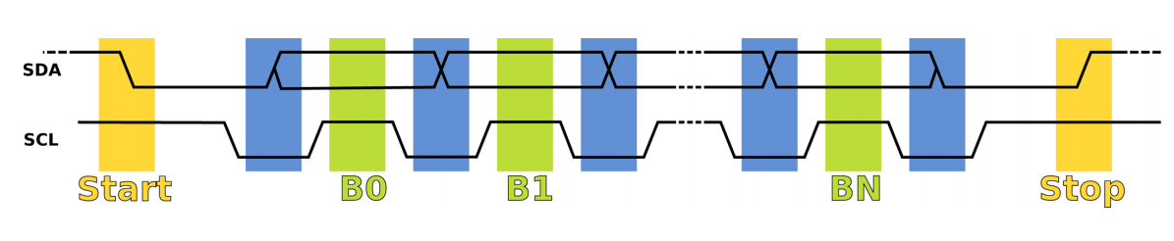
Figure 2 I2C Data Timing
I2C conversation starts with pulling SDA line low before start of clock, this is the start signal. Next, the master starts the clock with a low pulse. Data is then set up on the low clock phase and read out on the higher clock phase until the transaction is over. The clock is stopped, and the master sends the stop signal by releasing the SDA.
In order to allow a number of devices to use the same two lines, each slave needs to know when it’s being communicated to, which is done by an addressing scheme. Each device has a specific seven-bit address through which communication between the master and the device must start with. The eighth bit is reserved for a read/write direction bit that determines whether the master or slave is going to send data over the data line next.
A one/high-level directional bit means that the master expects to read data off the line while a zero/low-level bit means that the master is going write the data on the SDA.
It is important to know that, the device that is receiving the data has the responsibility of acknowledging that it has received the byte. It does so by the help of a ninth bit sent after every 8-bit byte. A low (ACK) bit indicates that a byte is acknowledged and signals that the sender should continue sending. A high (NACK) bit indicates that there was an error or that the transmitter should stop sending or that the whole communication is about to end, depending on the circumstances.

Atmega32 I2C Communication
I2C works in two modes namely,
- Master Mode
- Slave Mode
AVR atmega32 has a TWI module made up of a number of submodules as shown in the figure below.
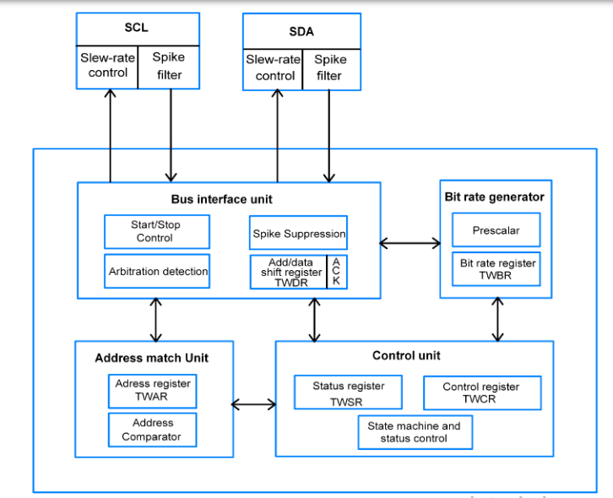
Figure 3 AVR Atmega32 I2C Module

Atmega32 I2C Module
SDA and SCL pins
- They are used to interface the TWI external based peripherals and the microcontroller.
- The output drivers contain a slew-rate limiter. The input stages contain a spike suppression unit which removes spikes shorter than 50 ns.
Bus Interface unit
- Contains Start/Stop control that is responsible for the generation and detection of START, REPEATED START, and STOP conditions.
- TWDR add/data shift register contain data to be transmitted and received.
- ACK bit receives ACK/NACK in transmitter mode and it is generated through software in receiving mode.
- The Spike suppression unit takes care of spikes while arbitration detection continuously monitors bus status and informs the control unit about it.
Addressing Match Unit
In slave mode, the Address match unit receives the incoming 7-bit address and compares with the address in TWAR (Two Wire Address Register) register to check whether it matches or not and upon match occur it intimate to control unit to take necessary action. It also considers the general call address if the TWGCE bit in TWAR is enabled
Control Unit
It contains the TWI control register (TWCR) and TWI status register (TWSR). It also controls the overall process of attention for necessary events, identifying events when occur, TWINT interrupts assertion, and update TWSR
Bit Rate Generator Unit
It controls the SCL in master mode to generate SCL frequency. The SCL frequency is calculated as shown below,
SCL frequency = (CPU CLK frequency)/ (16+2(TWBR)*4^TWPS)
Where; TWPS = value of a prescaler bit in TWSR

Registers in atmega32 I2C Module

TWBR: TWI Bit Rate Register
Used in generating SCL frequency while operating in master mode
TWBR7 | TWBR6 | TWBR5 | TWBR4 | TWBR3 | TWBR2 | TWBR1 | TWBR0
7 6 5 4 3 2 1 0

TWCR: TWI Control Register
This register controls all I2C communication.
TWINT | TWEA | TWSTA | TWSTO | TWWC | TWEA |  | TWIE
7 6 5 4 3 2 1 0
Bit 7 – TWINT: TWI interrupt bit
Set whenever TWI completes its current event. While I-bit in SREG and TWIE bit in TWCR is enabled then TWI interrupt vector is called whenever TWI interrupt occur.
TWI interrupt flag must be cleared by software by writing a logical one to it. This bit is not automatically cleared by hardware.
Bit 6 – TWEA: TWI enable acknowledgment bit
It is set in receiver mode to generate acknowledgment and cleared in transmit mode.
Bit 5 – TWSTA: TWI START condition bit
The master device sets this bit to generate START condition by monitoring free bus status to take control over the TWI bus.
Bit 4 – TWSTO: TWI STOP condition bit
The master device sets this bit to generate STOP condition to leave control over the TWI bus.
Bit 3 – TWWC: TWI write collision bit
Set when writing to the TWDR register before the current transmission is not complete i.e. TWINT is low.
Bit 2 – TWEN: TWI enable bit
Set to enables the TWI interface in the device and takes control over the I/O pins.
Bit 0 – TWIE: TWI interrupt enable bit
Used to enable TWI to interrupt routine while the I-bit of SREG is set as long as the TWINT flag is high.

TWSR: TWI Status Register
TWS7 | TWS6 | TWS5 | TWS4 | TWS3 |  | TWPS1 | TWPS0
7 6 5 4 3 2 1 0
Bit 7: Bit 3 – TWS7: TWS3: TWI Status bits
These bits show the status of TWI control and bus
Bit 1: Bit 0 – TWPS1: TWPS0: TWI Prescaler bits
These bits are used to set the prescaler used in bit rate formula to calculate SCL frequency. The prescaler is se as shown in the table below;

TWPS1 | TWPS0 | Exponent | Prescaler
0 | 0 | 0 | 1
0 | 1 | 1 | 4
1 | 0 | 2 | 16
1 | 1 | 3 | 64

TWDR: TWI Data Register
This register contains data to be transmitted or received. It is not writable while TWI is in process of shifting a byte.
7 6 5 4 3 2 1 0

TWAR: TWI Address Register
This register stores the TWI unit in slave mode. It is mostly used in multi-master systems
TWA6 | TWA5 | TWA4 | TWA3 | TWA2 | TWA1 | TWA0 | TWGCE
7 6 5 4 3 2 1 0
Bit 7: Bit 1 – TWA6: TWA0: TWI Address bits
These bits contain the address with which it (the device in slave mode) can be called by other masters in slave mode.
Bit 0 – TWGCE: TWI General Call Enable bit
When set it enables recognition of general call over the TWI bus

References
- Elliot Williams (2014). Make: AVR Programming
- https://www.electronicwings.com/avr-atmega/atmega1632-spi#
- https://www.electronicwings.com/avr-atmega/atmega1632-i2c#

